# ***The Future of Video Games: NVIDIA ACE***

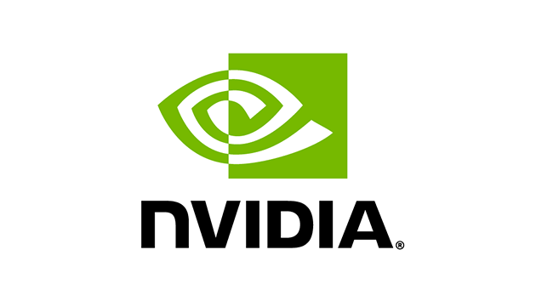

## 1. Introduction: Why NVIDIA ACE Matters in the Evolution of Game AI

Artificial Intelligence (AI) has revolutionized the video game industry, enabling increasingly complex and dynamic gameplay experiences. While early games used basic rule-based systems to simulate enemy behavior—such as the predictable paths of Pac-Man’s ghosts—modern games demand intelligent systems that can perceive, interpret, and respond to player actions in real-time. This shift has been driven by advancements in machine learning, natural language processing, and generative models.

At the forefront of this evolution is NVIDIA’s Avatar Cloud Engine (ACE), a cutting-edge AI platform specifically designed to transform non-player character (NPC) interactions. ACE enables developers to create fully dynamic characters that speak, listen, interpret, and act based on player input. Its use of real-time generative AI, speech synthesis, facial animation, and compact decision-making models positions it as a defining innovation in the next generation of gaming. As such, this report explores NVIDIA ACE in depth—examining how it works, where it's already being applied, and how it could shape the future of interactive digital entertainment.

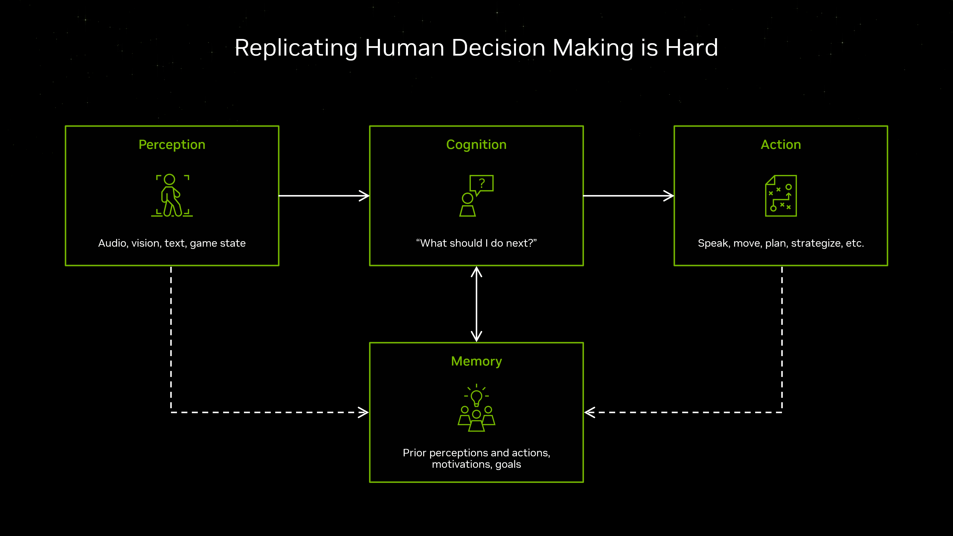

## 2. Under the Hood: How NVIDIA ACE Works

NVIDIA ACE integrates a range of AI technologies into a unified system that powers lifelike NPCs capable of rich, real-time interaction. Key components include:

* **NVIDIA Riva (Speech AI)**: Enables NPCs to listen and speak using real-time speech recognition and natural language synthesis.
* **NVIDIA Audio2Face**: Translates voice inputs into realistic facial animations, allowing for synchronized lip movement and emotive responses.
* **NVIDIA NeMo and Small Language Models (SLMs)**: Power the understanding and generation of contextual dialogue. These language models are optimized to run locally or in the cloud.
* **Decision-Making Systems**: Lightweight neural networks process environment context and guide NPCs to act intelligently, making conversations not only coherent but responsive to player behavior.
* **Real-Time Integration**: All of the above models work within a pipeline that runs on RTX-powered systems or cloud environments, ensuring high performance and low latency.

Together, these tools make ACE far more than a chatbot—it’s a full stack that allows characters to behave like thinking, feeling participants in the game world.

SSSS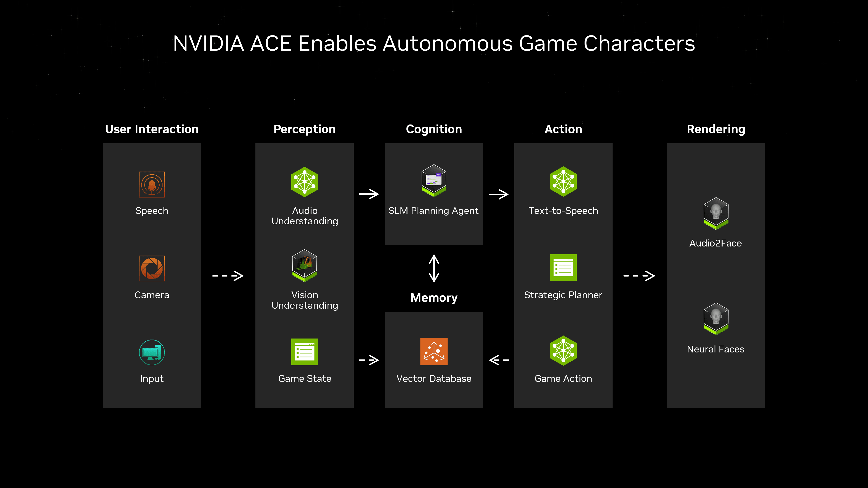

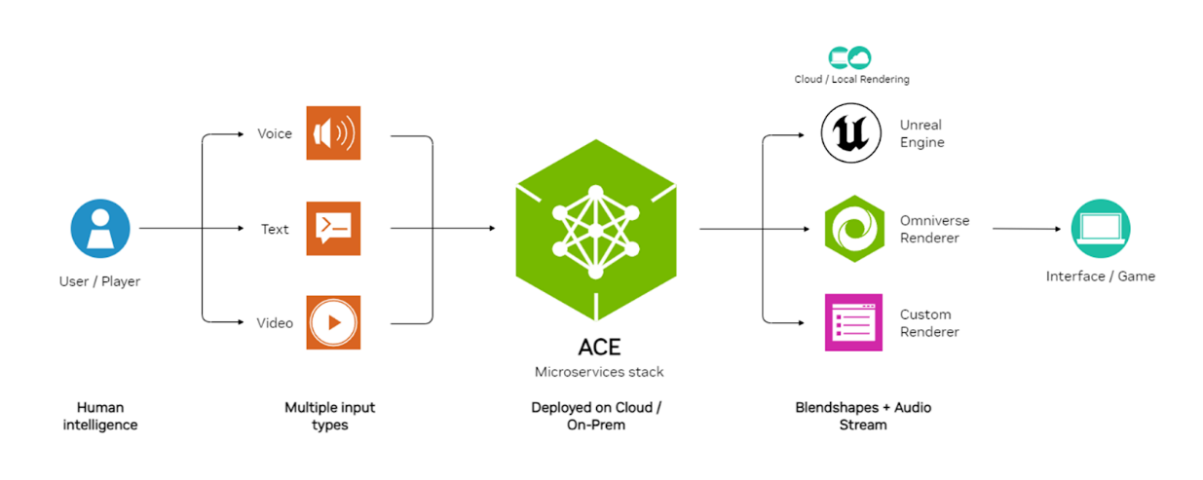

## 3. Where It’s Being Used: PUBG, Naraka, and Real-World Demos

NVIDIA ACE is already being tested in commercial game environments:

* **PUBG (PlayerUnknown's Battlegrounds)**: At CES 2024, NVIDIA showcased an ACE-powered NPC called "DJ," a bar owner in a cyberpunk-themed PUBG world. The player engaged DJ using voice, triggering personalized dialogue and dynamic emotional responses. DJ didn’t just talk—he reacted to the tone, context, and direction of the conversation.
* **Naraka: Bladepoint**: Another real-world implementation of ACE's digital companion system, providing dynamic voice-responsive teammates that adjust tactics based on player voice input.

These implementations demonstrate how ACE advances NPCs from pre-recorded, tree-branch dialogues to fluid, emergent conversations that adapt to player intent.



## 4. The Road Ahead: NVIDIA ACE and the Future of Game Development

Looking forward, NVIDIA ACE could influence every aspect of how games are created and experienced:

* **Customizable NPC Memory**: Future versions of ACE could allow characters to retain memory of past interactions, altering dialogue and behavior based on relationship history.
* **Scalable Worldbuilding**: Developers can use ACE to populate vast open worlds with intelligent agents that respond to players uniquely, reducing manual scripting and VO recording.
* **Player-Created Narratives**: With AI-powered dialogue and character memory, ACE could help games generate narrative arcs that are shaped entirely by the player’s style and decisions.
* **Cross-Platform Deployment**: As cloud gaming expands, ACE’s ability to run on both local GPUs and server-based infrastructure will allow developers to use it across platforms.

These trends point toward a world where AI is not just an assistive tool but a co-creator of digital experiences.

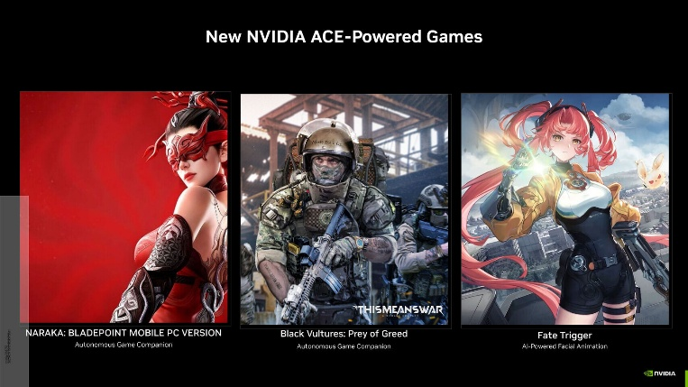

## 5. Ethical, Social, and Technical Implications of ACE

While NVIDIA ACE offers groundbreaking potential, it also raises critical challenges:

* **Voice Actor Replacement and Consent**: Generating speech and expressions based on AI may blur the lines of performance rights. Transparency and ethical standards are crucial when using voice synthesis.
* **Bias in Dialogue Generation**: Since ACE models are trained on internet-scale text corpora, developers must rigorously test to prevent toxic or biased responses in dialogue.
* **Player Data Privacy**: Real-time voice interaction requires careful handling of user data. Games using ACE must implement clear privacy policies and consent mechanisms.
* **Overdependence on AI for Narrative**: Relying too heavily on ACE-generated content may dilute human-authored storytelling unless balanced carefully.

Addressing these challenges head-on will ensure that ACE enhances creativity and immersion without compromising ethical standards or gameplay quality.

## 6. Other Applications of AI in Video Games

While NVIDIA ACE represents one of the most comprehensive and advanced AI solutions in gaming, it exists within a broader landscape of innovative AI applications that continue to shape modern game development and gameplay experiences:

* **NPC Behavior**: Beyond ACE, developers employ reinforcement learning, utility-based AI, and behavior trees to simulate intelligent NPC decision-making. This helps create more lifelike and reactive characters, whether in stealth-based games like Hitman or open-world RPGs like The Witcher 3.
* **Adaptive Boss Fights (Action Recognition)**: Using action recognition and predictive modeling, some games now feature bosses that dynamically adapt their strategies based on the player's actions. This prevents repetitive gameplay patterns and maintains challenge by forcing players to constantly evolve their tactics.
* **Content Generation**: Procedural generation, guided by machine learning, is used to auto-generate landscapes, quests, items, and dialogue. This dramatically extends replayability and supports indie developers by reducing the resources needed to build vast game worlds.
* **Dynamic Difficulty Adjustment**: AI systems analyze player performance in real time and adjust game difficulty accordingly. For example, in games like Resident Evil 4 (Remake), enemy behavior subtly shifts to maintain optimal challenge without the player needing to adjust settings.
* **AI for Playtesting and QA**: Game studios now use AI bots to simulate human gameplay for identifying bugs and testing balance, reducing the manual workload for quality assurance teams.
* **AI-Enhanced Animation and Physics**: Neural networks and generative models are being used to animate characters procedurally, reducing reliance on keyframe animation and enabling smoother, more natural motion.

These applications showcase the versatility of AI in gaming—ranging from narrative development to mechanics refinement—and reinforce how platforms like NVIDIA ACE fit within a much larger innovation ecosystem.



## References

* NVIDIA. (n.d.). *NVIDIA ACE developer page*. NVIDIA. <https://developer.nvidia.com/ace>
* NVIDIA. (2024, January 8). *NVIDIA ACE enables autonomous AI companions in games like PUBG and Naraka: Bladepoint*. NVIDIA. <https://www.nvidia.com/en-us/geforce/news/nvidia-ace-autonomous-ai-companions-pubg-naraka-bladepoint/>
* Warren, T. (2025, January 6). *NVIDIA’s new ACE tech brings AI NPCs to games like PUBG*. *The Verge*. <https://www.theverge.com/2025/1/6/24337949/nvidia-ace-ai-npcs-pubg-ally-teammate>
* NVIDIA. (2024). *NVIDIA ACE demo video* [Video]. YouTube. <https://youtu.be/-8XeiZ4djKw?si=aWyozTm_QPjkYXpM>
* Cure, D. (2023). *AI-powered NPCs for Skyrim VR*. Nexus Mods. <https://www.nexusmods.com/skyrimspecialedition/mods/98631>
* AI Business. (2023, October 5). *How Ubisoft is using AI in game development*. AI Business. <https://aibusiness.com/ml/how-ubisoft-is-using-ai-in-game-development>
* Ubisoft Montreal. (n.d.). *Ubisoft La Forge presents the Commit Assistant*. Ubisoft. <https://montreal.ubisoft.com/en/ubisoft-la-forge-presents-the-commit-assistant/>
* Plante, C. (2023, March 21). *Ubisoft’s Ghostwriter AI tool helps writers generate NPC dialogue*. *Polygon*. <https://www.polygon.com/ai-artificial-intelligence/23652201/ubisoft-ai-writing-tool-ghostwriter>
* Hern, A. (2024, March 29). *‘I feel like a relic’: How AI is affecting video game actors*. *The Guardian*. <https://www.theguardian.com/technology/2024/mar/29/how-ai-is-affecting-video-game-actors>
* Ramer, H. (2024, March 20). *AI voice cloning raises concerns among video game actors*. *Associated Press*. <https://apnews.com/article/video-game-voice-actors-ai-technology-voicing-66cf6c3c7321ad4368c02921af31c19d>
* Unity Technologies. (n.d.). *Unity ML-Agents Toolkit overview*. <https://unity-technologies.github.io/ml-agents/ML-Agents-Overview/>
* Big Cloud. (n.d.). *The evolution of AI in gaming*. Big Cloud. <https://bigcloud.global/the-evolution-of-ai-in-gaming/>
* Vincent, J. (2018, August 28). *OpenAI bots lose in Dota 2 at The International tournament*. *The Verge*. <https://www.theverge.com/2018/8/28/17787610/openai-dota-2-bots-ai-lost-international-reinforcement-learning>
* GameSpot. (2024). *NVIDIA ACE NPCs trailer* [Video]. YouTube. <https://www.youtube.com/watch?v=HYM3P-eL7QU>